Trying to create a fillable PDF from an excel doc that I had used before (the one I’m attempting is a revision)
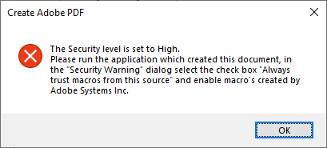

The Script Error upon Sign In/Out
