DELL Updated:
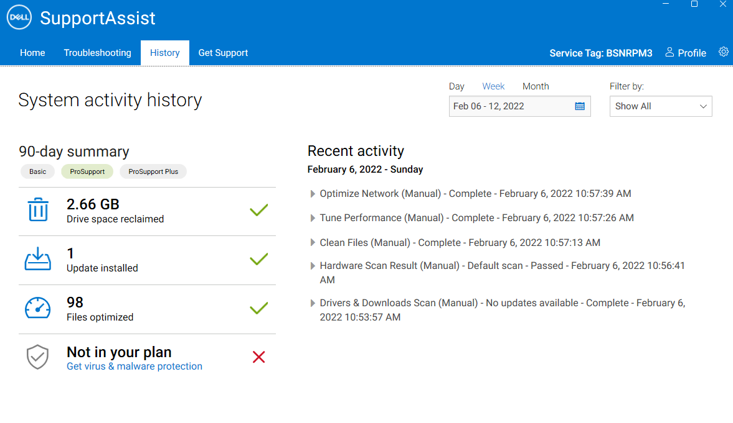
If I use this installer:
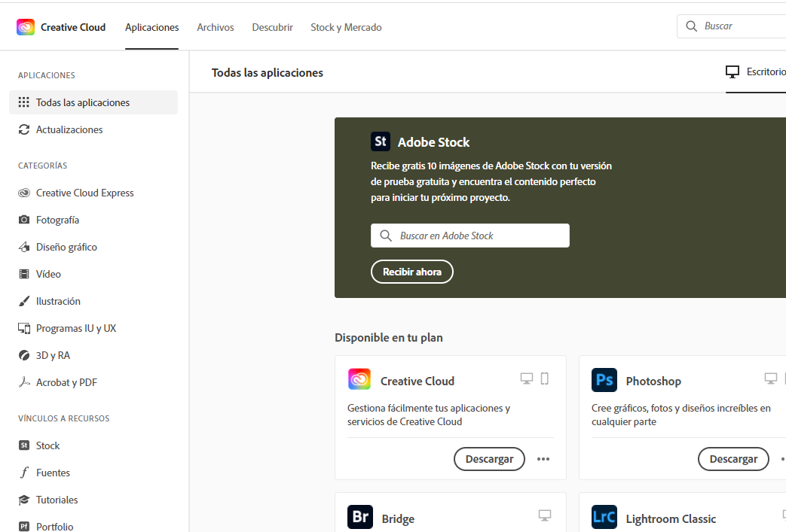

First time I click on install, after introducing credentials in the browser, it installation did not go frward (loading). Second time it went correct:
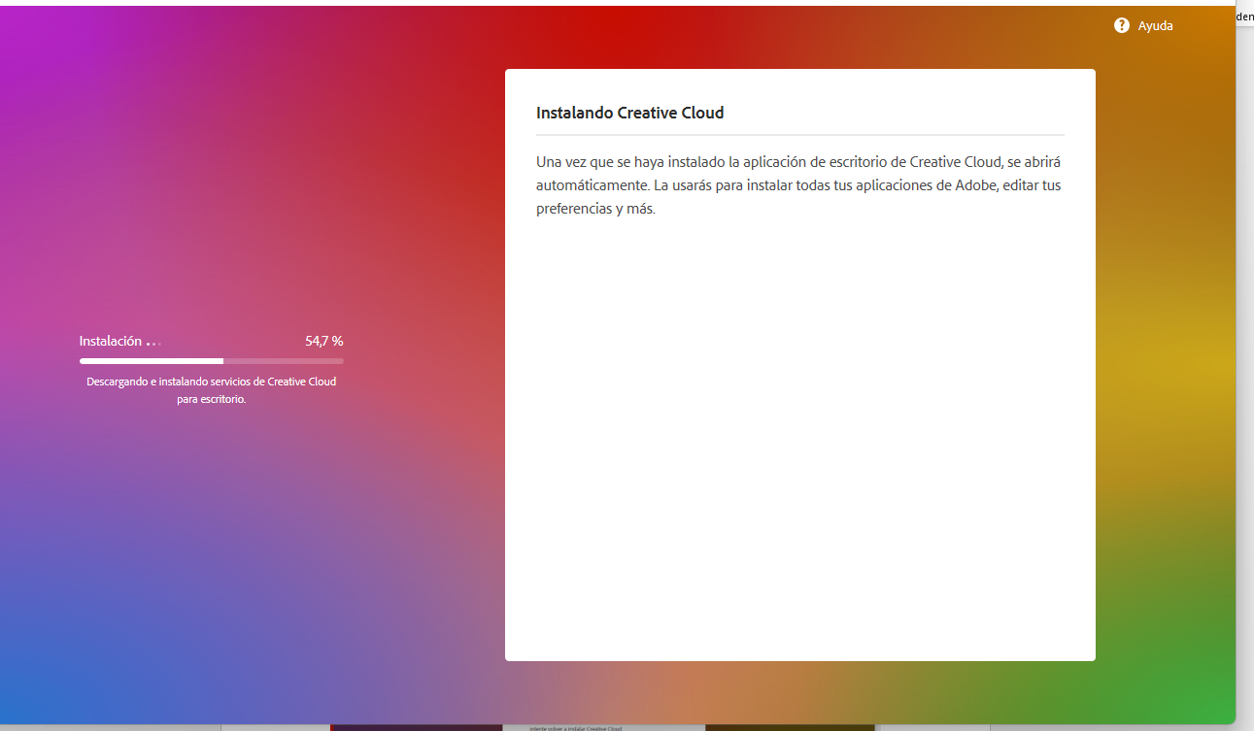
Then it says (in english): “Openning Creative Cloud”
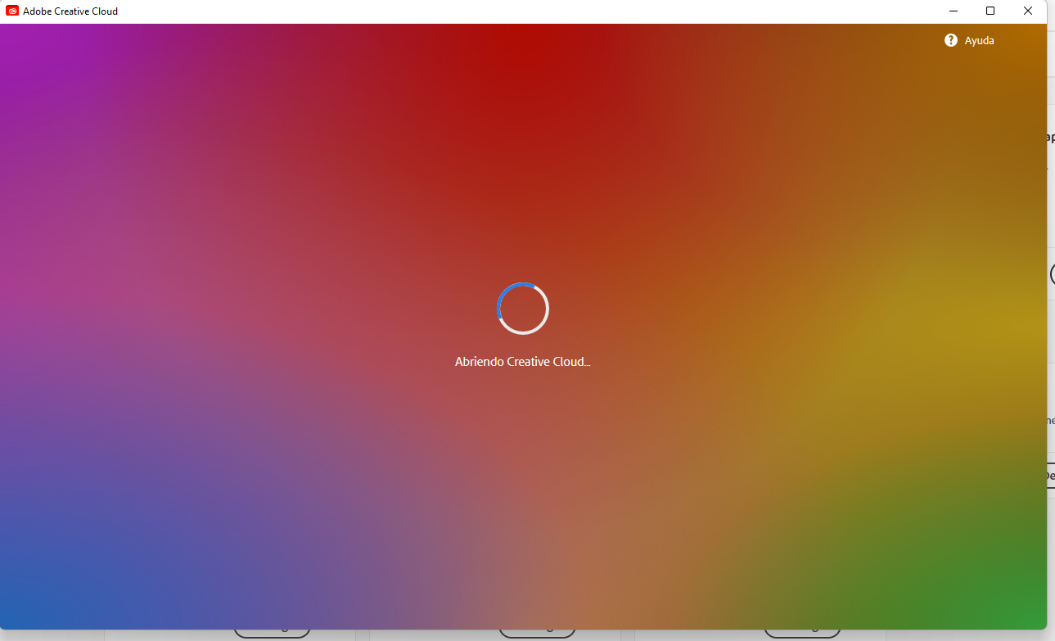

And then “Loading Creative Cloud”… but remains here…

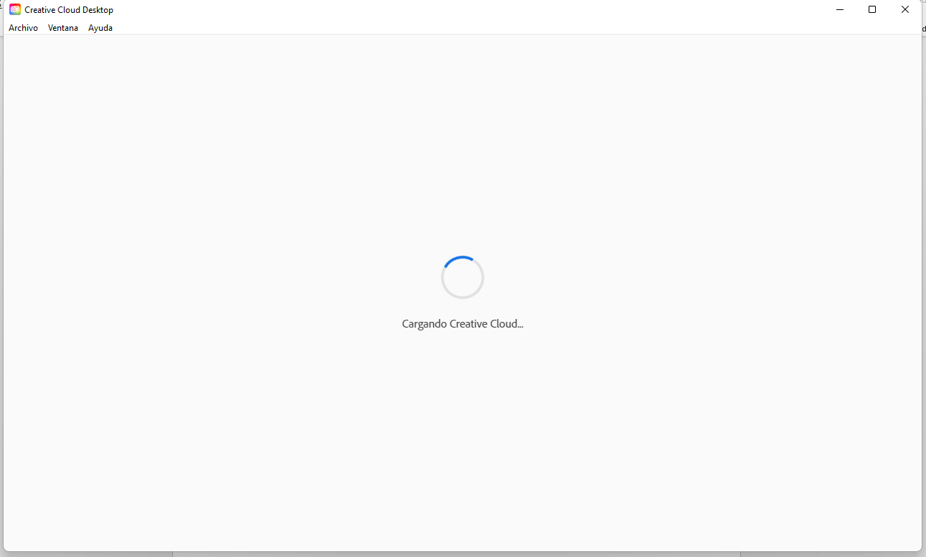

Until appears the blue message:
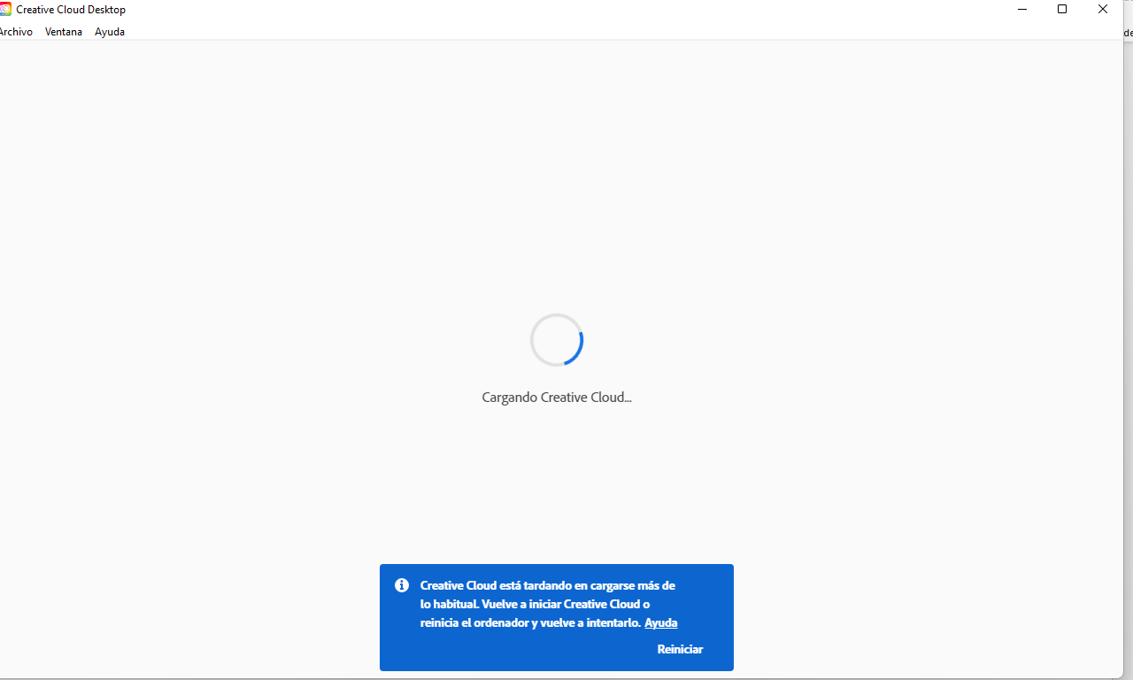

After may attenmps, one of them, I have obtained this error:
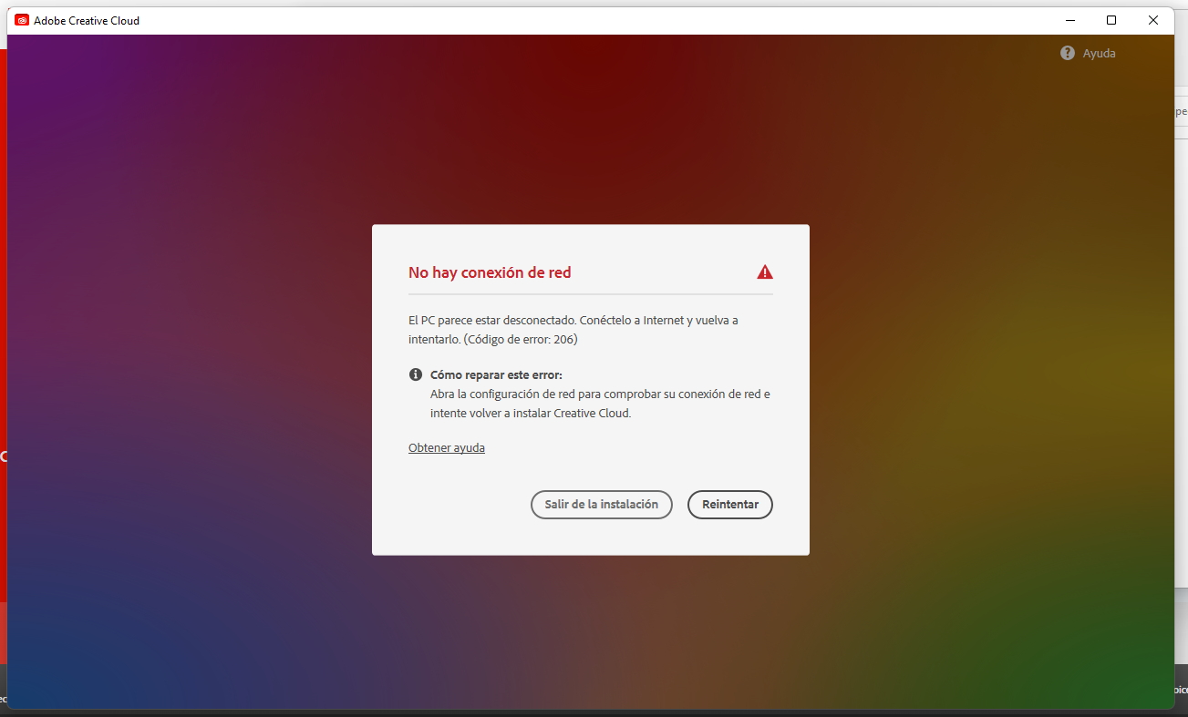
Which in English says: the computer seems to be disconnected. Connected to the internet and try again (error 206).
How to repair: Open the network configuration to check your connection and try to reinstall Creative cloud.

Maybe the error when trying to install adobe reader is related to the same reason creative cloud is loading forever:
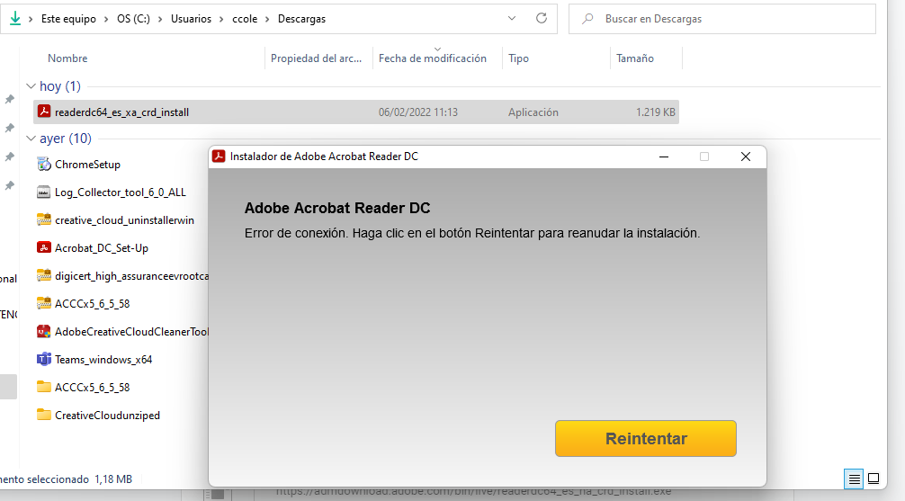
Translated in English means: Connection Error

This is the same explanation as I wrote in the post:

-Hello and thanks for trying to help. I’m going to answer your questions: My new Dell Optiplex 7780 All-in-one that comes with Windows 11 is totally updated included BIOS , drivers, …everything. My computer works perfect , diagnostics are ok and it is a Intel i7 with 32GB ad 1 TB of HD. I use the full suite of Microsoft 365 (Outlook, Word, Excel, Teams, Todo,Onenote..) all works perfect. Also, my internet connection it is fine. Let me tell you that I already used the adobe cleaning tool and problem was NOT fixed
What happens is: I can install adobe creative cloud but… at the end, it opens an at the center I get the message (I’m translated from Spanish) that says: “Loading creative cloud…” and in a few minutes, below the window, appears another blue message that says it's taking longer than usual. It advises to restart the computer and relaunch the app (but the same happens if I do). Also, I tried to disable all the security that comes in Windows 11 just to check if that might be the problem but it seems that is not the problem.
First adobe product I tried to install even before than “creative cloud” it was (from Adobe site), Adobe Reader but was not possible (and still is not possible). I get a “connection error” at the beginning of the process or using another way to install, at the middle of the process it opens “creative cloud” and I get again with the “loading creative cloud..”.
I have use also the adobe logs collector. I have included the generated files and some screenshots about the process and the erros I get.
It looks like the problem, I believe, is that for some reason, creative cloud CAN NOT CONNECT to the Adobe Servers and this reason must rely in some Windows 11 problem with adobe tools (I disabled thw Windows 11 firewall and this is not fixed). Also, my old computer with Windows 10 has Creative cloud , in the same home wireless network and it does work as always. However, I need the new computer…
Please help.

