Before_During_After (300ppi)
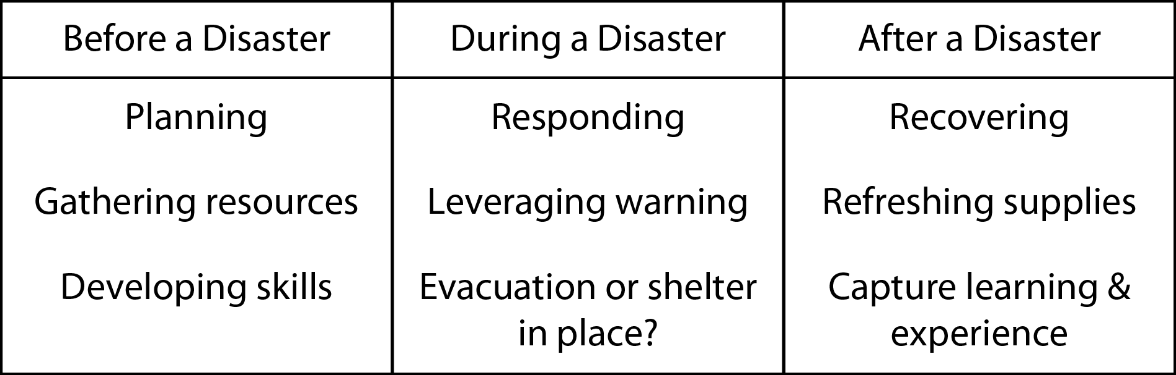

Before_During_After (72ppi)
