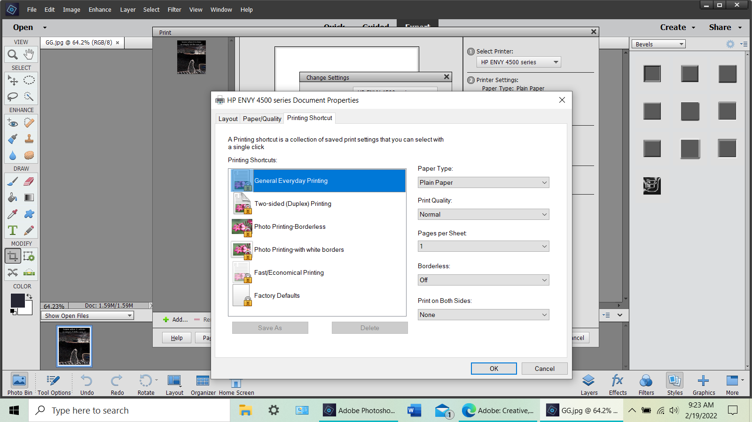

chat support sent me to this link:
Troubleshoot Photoshop printing problems (adobe.com)
Navigate to Photoshop's Preferences folder.
Windows 10: Users/[user name]/AppData/Roaming/Adobe/Adobe Photoshop [version]/Adobe Photoshop [version] Settings

